- Go to register.oasa.ca, the log in page for the OASA Membership Registration System.
If you are a new member go to the Sign up here.
If you have already registered sign in with your email and password.
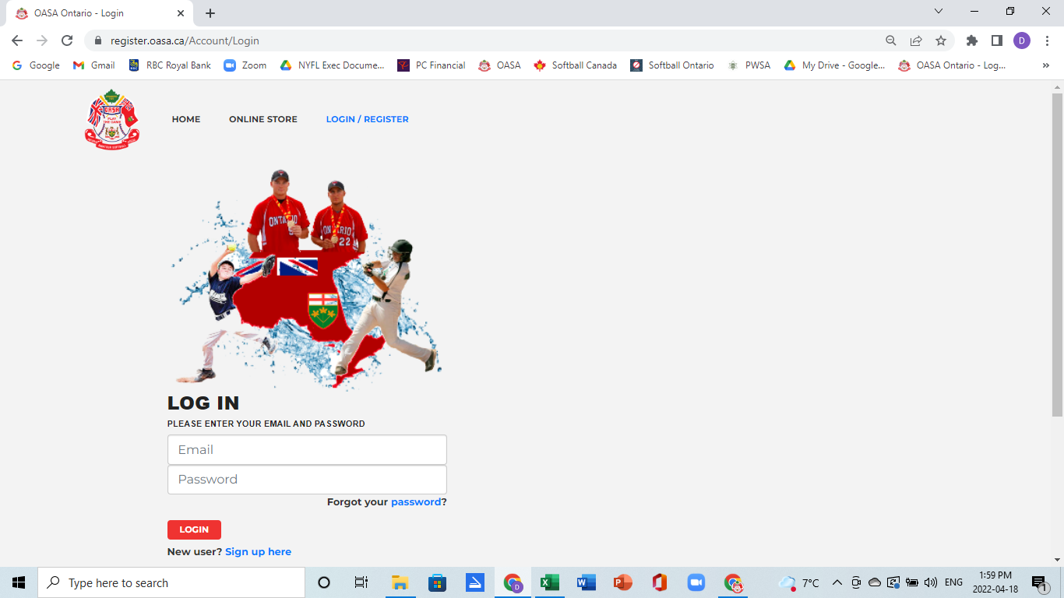
- New members need to create a record. Each record on the MRS requires a unique email address. For families that have multiple individuals that use the same email address (i.e. minor children using parents email, or all members of a family using a common email address) each individual will need to create a unique record by adding a + sign and name before the @ sign in the email. For example,
Dave Northern dave.northern1@gmail
John Northern dave.northern1+john@gmail.com
All emails will be sent to the primary email address, but each individual will have a unique record created on the system.
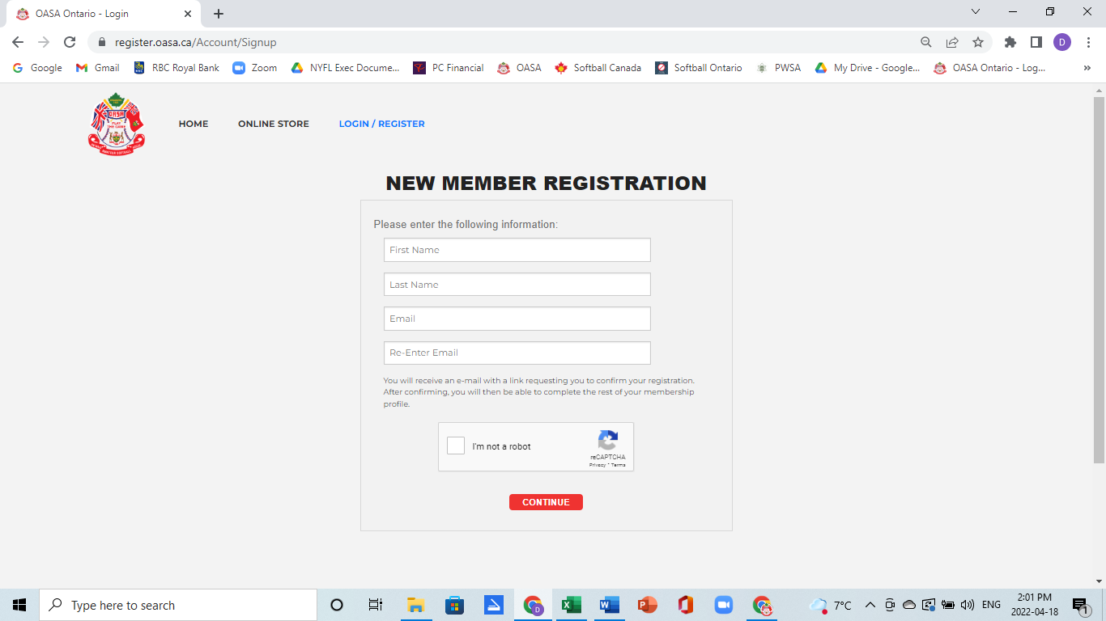
- Once a new member registers they will get a welcome email sent to them with a link back to the MRS system to complete the registration process.
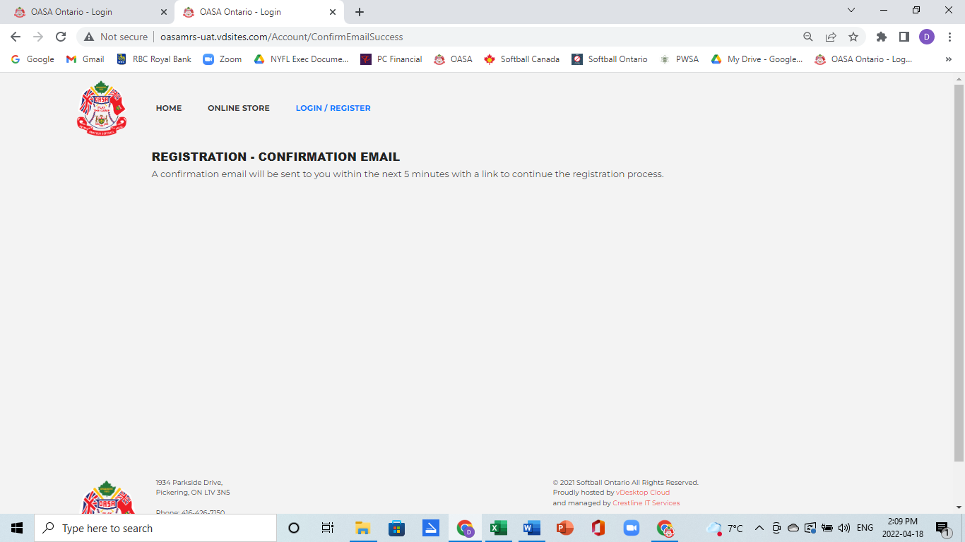

- If you do not receive the email in your inbox check your junk mail folder in case it happens to have been sent there. To complete the registration process click on the link.
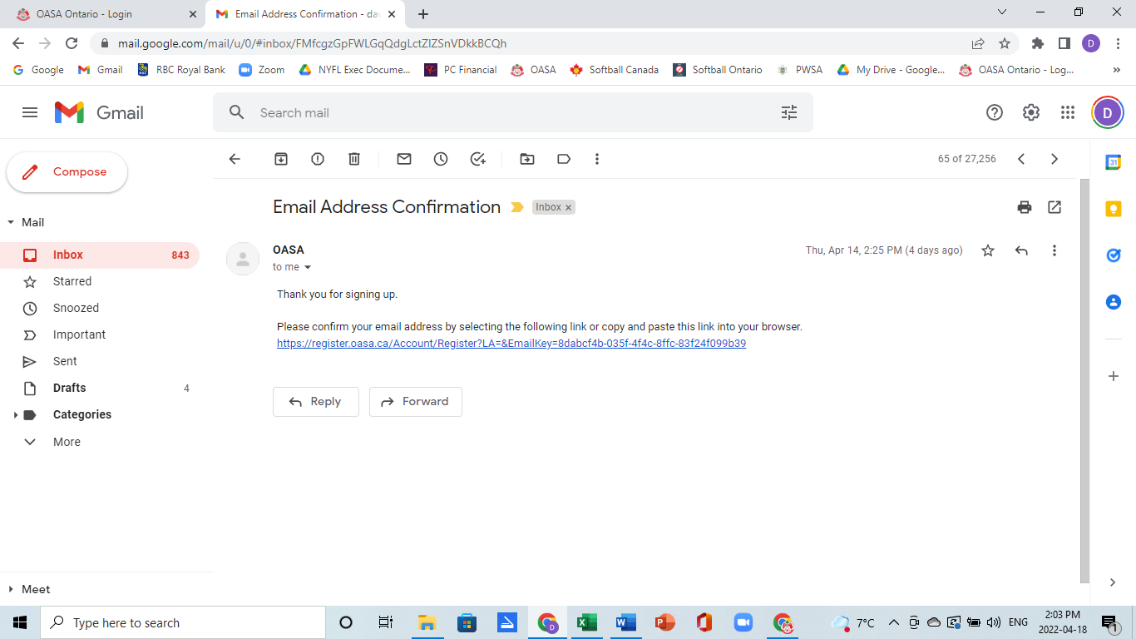
- Members will be returned to the MRS to complete the registration process. Anyone with an NCCP# needs to input it to assist us in confirming all certification levels for coaches and managers.
If you have a Respect in Sport # please input it as well.
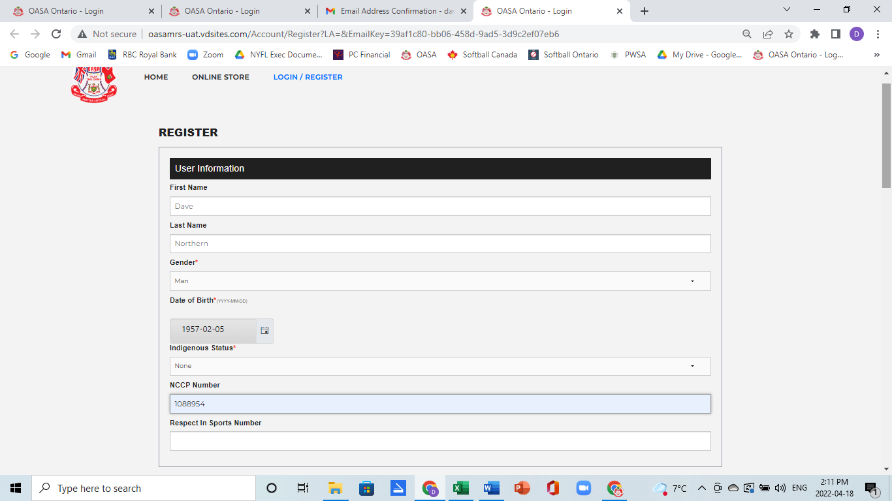

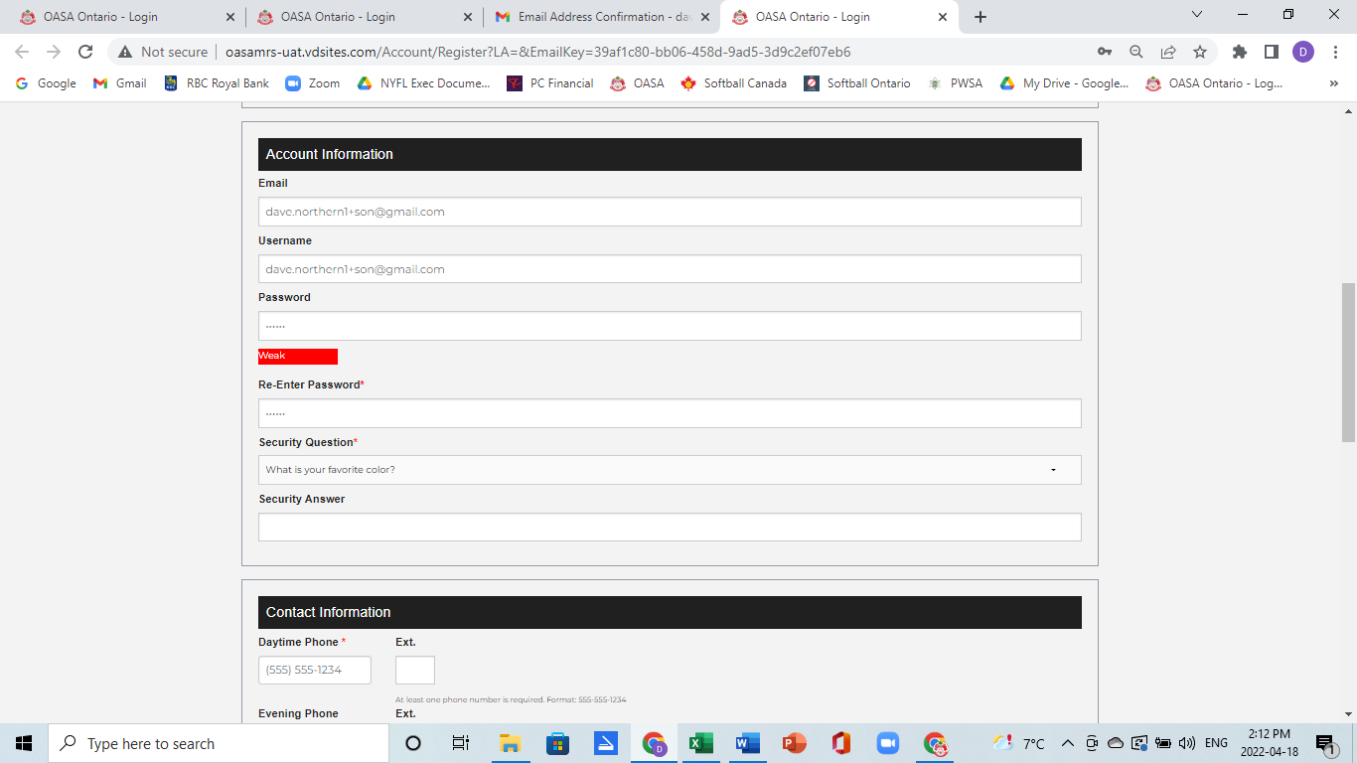
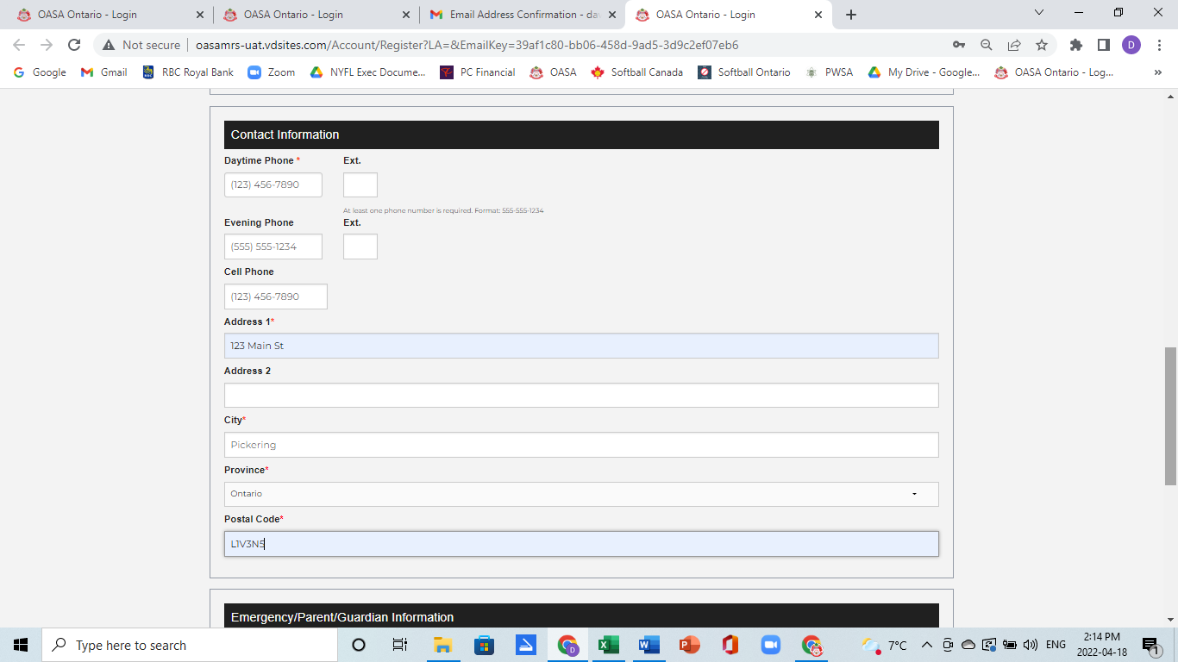

- All new players to OASA in 2022 will need to provide proof of their date of birth as this is the first year on this new system. Please take a picture or scan it and attach it to your membership record. Once the information has been submitted it will only be able to be seen by system administrators who will be verifying it from OASA’s perspective.
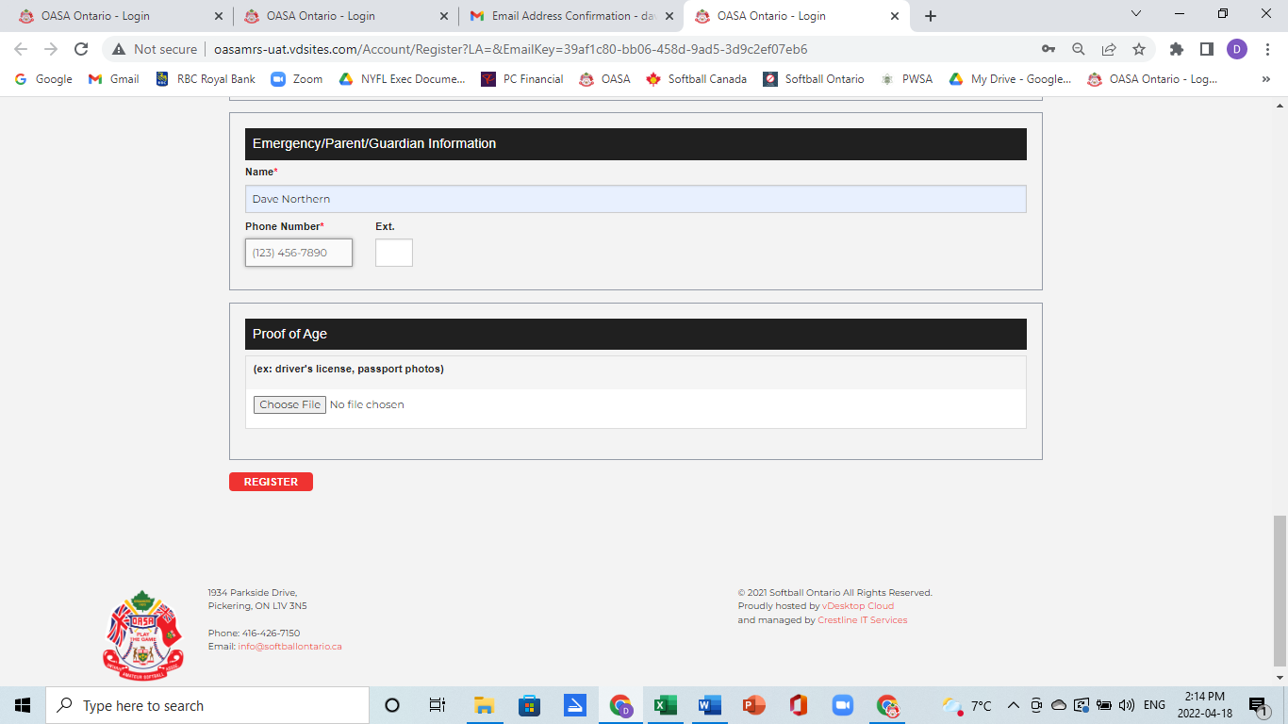
- Once an individual has completed their personal information they will need to select what role and what association they are going to be associated with.
Each role will have 1 or more waiver forms that will be presented that will need to be acknowledged as being read and understood to move forward.
Potential roles are:
Association Contact – typically the President or a senior executive. In the case of an independent team that is not part of an association the Head Coach or Manager can take on this role.
Head Coach, Assistant Coach, Team Manager – the staff of each team.
Player – all players.
Individuals can take on more than 1 role as well as be part of more than 1 Association.
Each person must be attached to an Association (Independent Team). A drop down list of all of the associations / independent teams that we are aware of will be presented for members to select from. If after scrolling through the full listing, you do not see your association / independent team name please do not proceed. Contact registrar@oasa.ca to advise which association / independent team you are associated with and we will update the drop down list or advise you which one for you to use.
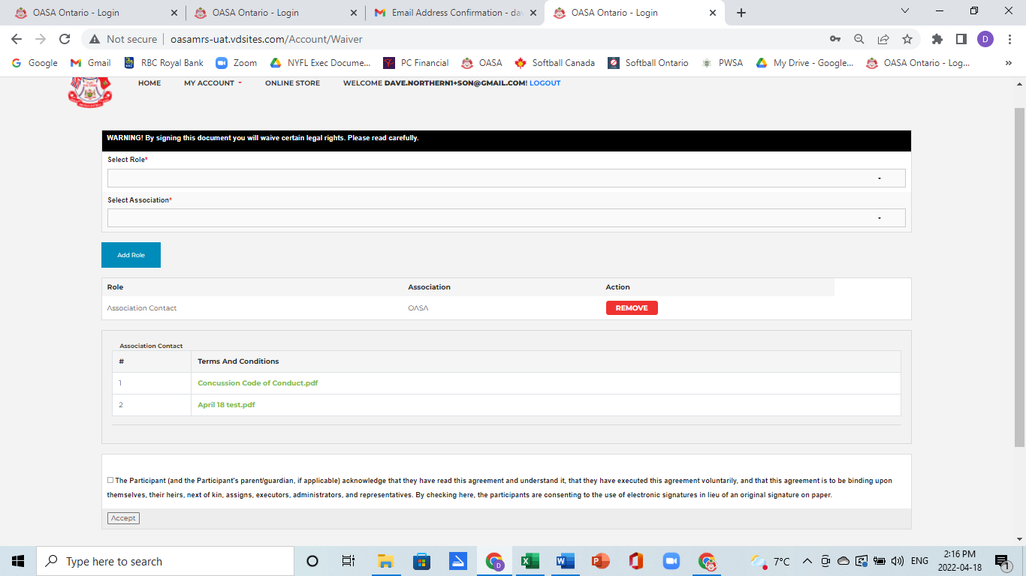
- After completing the roles and association you will be presented with a dashboard page showing which roles you are approved for within each association.
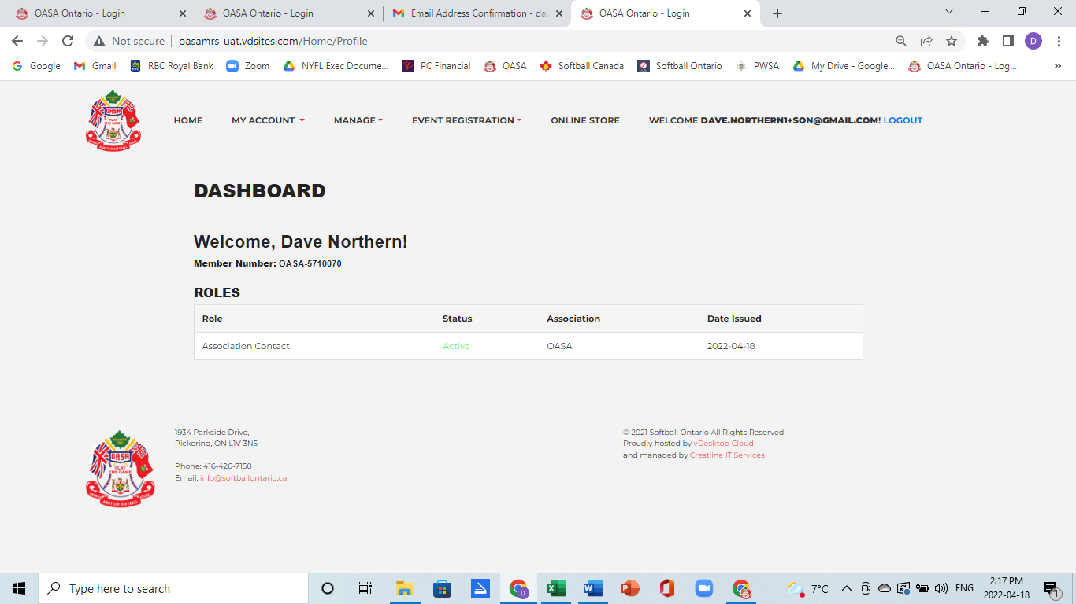

- Association Contacts are not charged an annual fee. Coaches, Managers and Players are all charged a $15 annual fee that can be paid either by credit card or by e transfer. No matter how many roles or teams or associations an individual registers for they will only be charged one $15 fee.
If you pay by credit card and the transaction is approved you will automatically be moved into an active status. If you want to pay by e transfer your status will show as pending until you make the e transfer from your online banking system and the payment is confirmed as being received. E transfers are to be sent to payment@softballontario.ca.

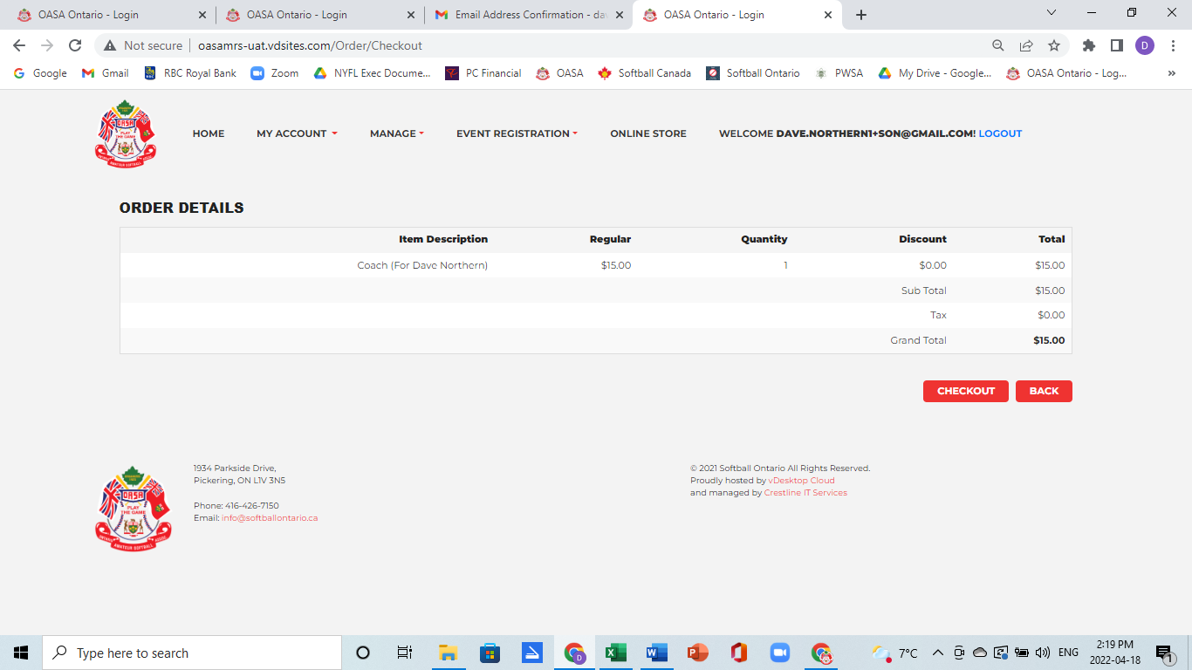
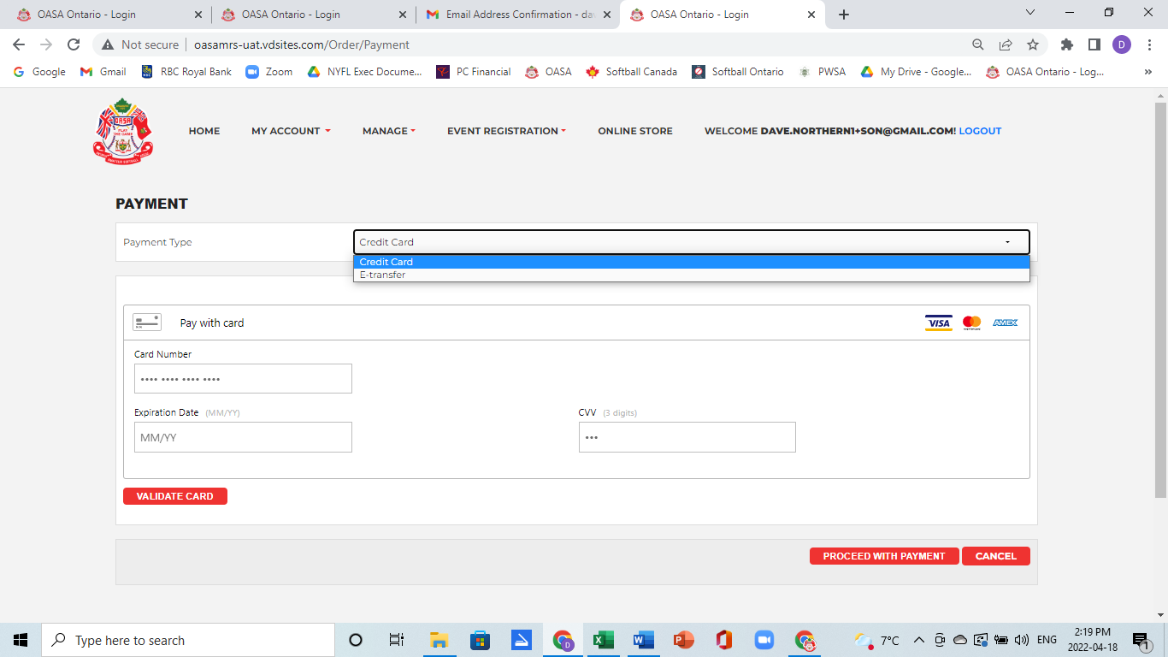
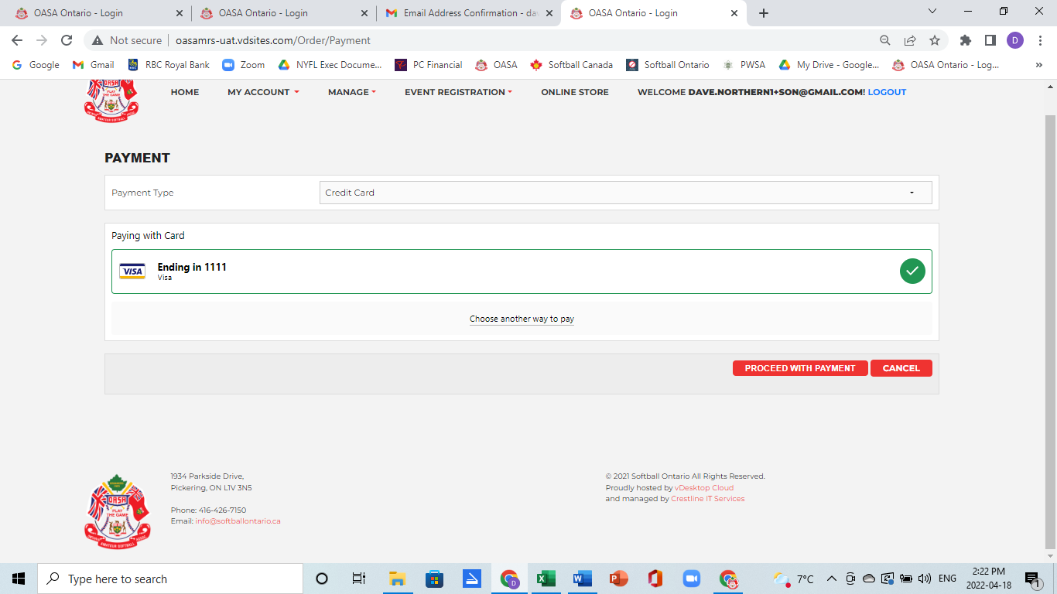
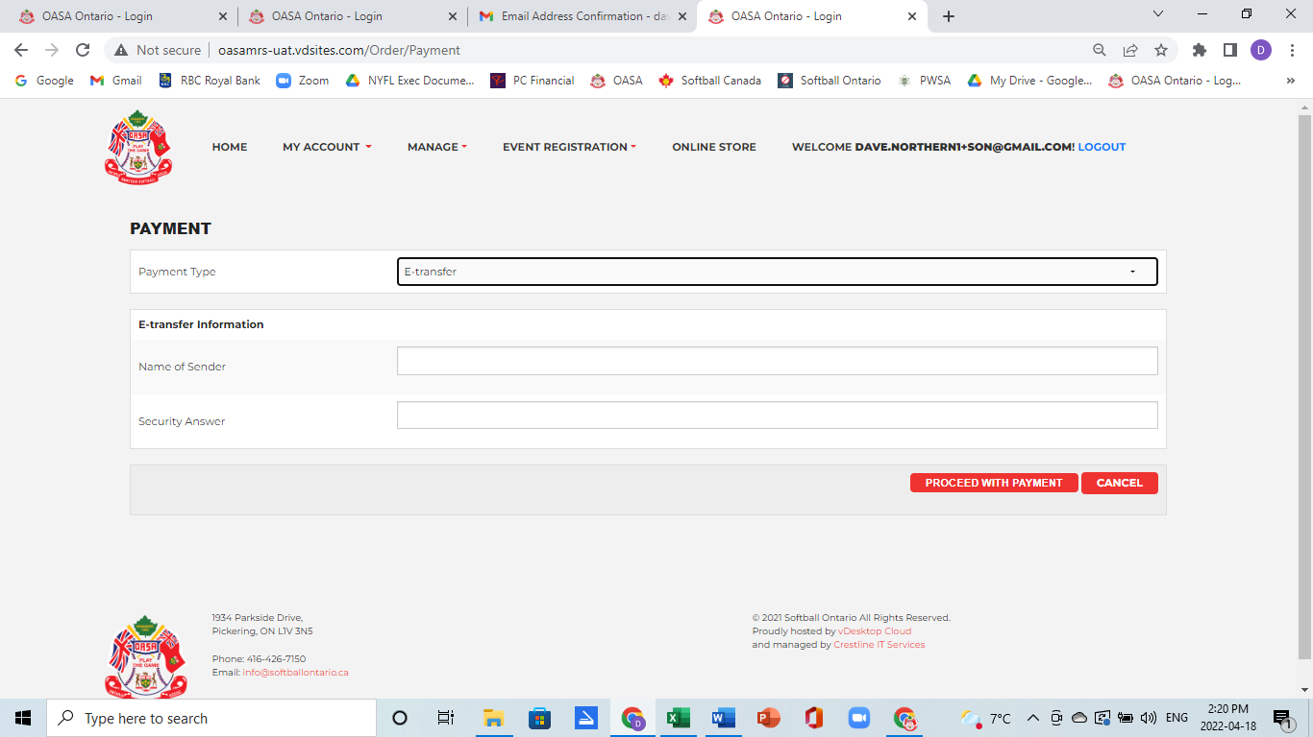

- If you are an Association Contact you will be responsible for creating the teams in your association within the MRS. You will need to go back into the system and go the Manage drop down and select Teams. From here you will need to input your Team Name (i.e. Oshawa Double B), Division (U9, U11, U13, U15, U17, U20, U23, Intermediate, Masters) and staff names (which will be from those staff that have registered for that role within your association). Then you will Create the team. If you have more than 1 team that you are the Association Contact for, you will be able to create each of the teams required. Teams must be created before players can be assigned to them.
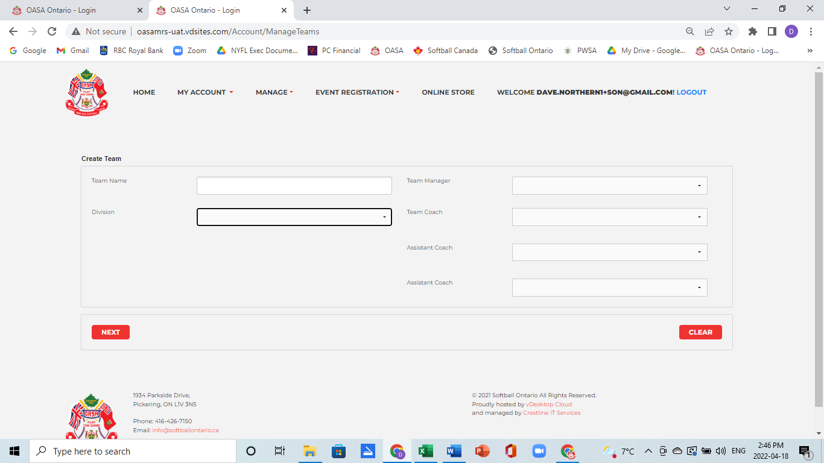
- After the Association and the Team have been created individual players will be allowed to register themselves. Every player must indicate an Association when they register. The Association Contact or the Head Coach or the Manager will then be able to go in under the Manage Teams tab and Add Players from the list of Active players under that Association to their team. Only players that are part of that Association will be displayed to be selected and placed on a team.
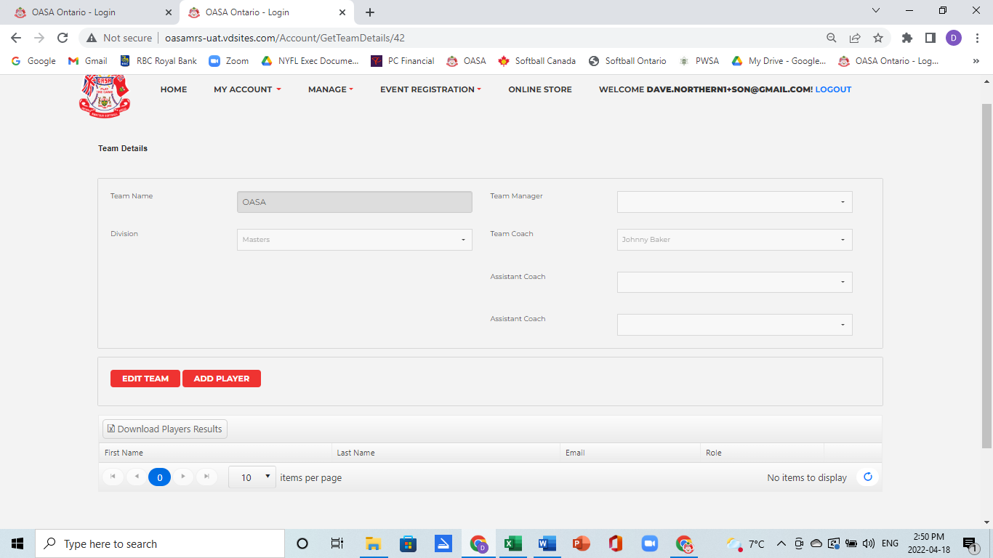

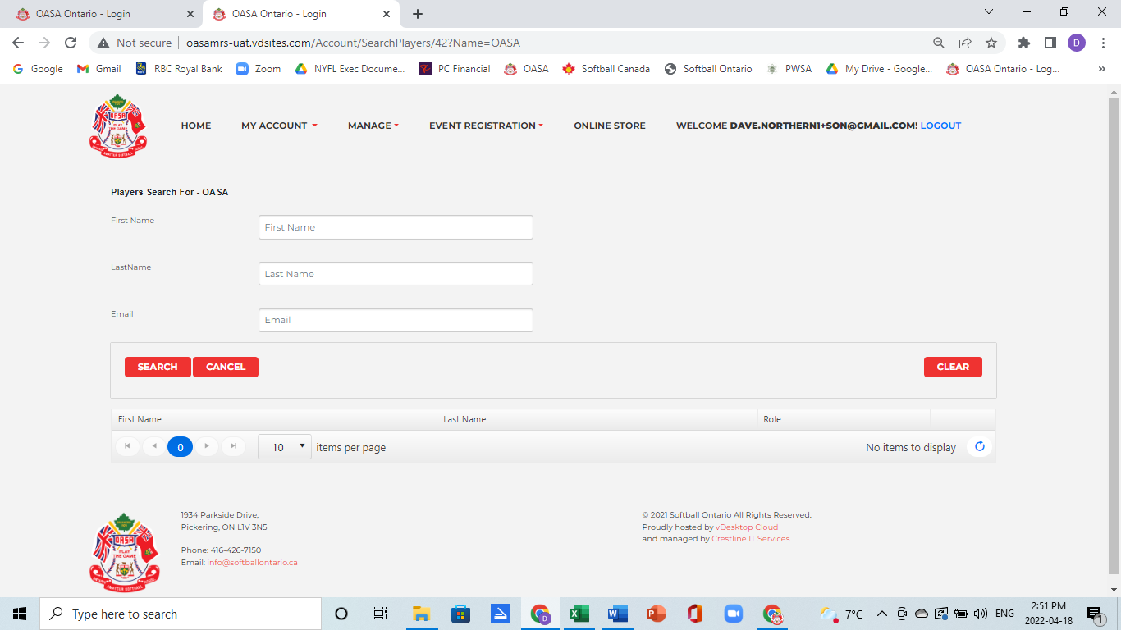

- Every individual that registers will be able to view their profile and be able to update personal information on their profile.
