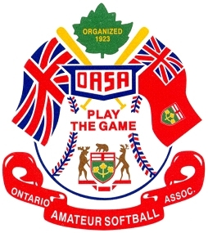
Ontario Amateur Softball Association
Executive Nomination
Instructions: 1. Refer to Article IV.4 Nominations – Official By-Laws
2. Additional nominations may be submitted on a second form
3. The Secretary must receive all nominations by December 1

Karen Mills
OASA Secretary
7 Sarah Street
Napanee, ON K7R 3J4
613-354-0828 millsy@live.ca

OFFICERS | NAME OF NOMINEE | TELEPHONE #
President
Executive Vice President
Vice President
Vice President
Secretary
Treasurer
Six Executive at Large | 1.
 | 2.
 | 3.
 | 4.
 | 5.
 | 6.
Printed Name of Nominator
Signature of Nominator
Nominator’s Centre
Date
Office Use Only | Date Received
Office Use Only | Received by

